Purley Jubilee Football Club
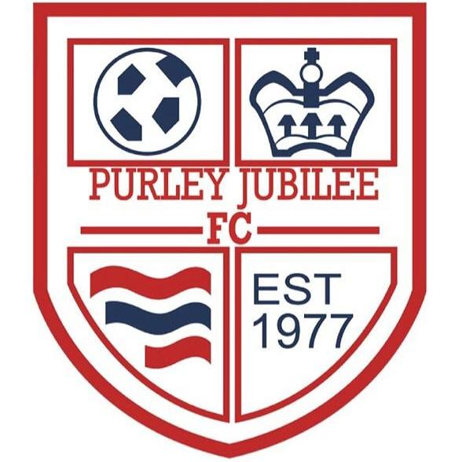

Welcome Pack

Season 2023/24

https://www. facebook.com/groups/557606194351004/

https://purleyjubileefc.co.uk/
Contents

An introduction to Purley Jubilee Football Club 1
Club Officials 3
Annual General Meeting 3
Training 3
Matches 3
Subscription Fees 4
Football Kits 4
Health and Safety 5
Safeguarding 5
Football for all – children with additional needs 5
Sponsorship 5
Opportunities 5
Presentation Evening 6
Fund Raising 6
Data Privacy Notice 6
Code of conduct 7
Anti-bullying policy 7
Social Media guidelines 7
Appendix 1 – FA “Respect” campaign: code of conduct & anti-bullying
policy 8
Appendix 2 – Purley Jubilee Referees programme 14
Appendix 3 – Social Media guidelines 15

An introduction to Purley Jubilee Football Club
Welcome to Purley Jubilee FC. We have been providing opportunities for children to learn and enjoy playing football for over 40 years.
We are proud to be a FA Chartered Youth Club adhering to all FA guidelines with regards to safeguarding. All our coaches are at least FA Level 1 qualified.
We are a not-for-profit organisation and run entirely by volunteers. All monies generated through subscriptions, sponsorship and fundraising are used by the club to improve the football experience of the players, parents, and coaches. We pride ourselves on being the best value club in the area, whilst providing first class facilities and coaching for our teams to play and train at.

Club Officials
Chairman | Steve Chinn | schinn1907@gmail.com
Vice Chairwoman | Thea Roberts | theajane1410@icloud.com
Treasurer | Nick Topazio | Nick.topazio@btinternet.com
Club Secretary | Cathy Walls | cefarrow@hotmail.com
Child welfare | Emma Basden | cwopurleyjubliee@gmail.com
Social Secretary | Samantha Parker  Kala Dutton | Samanthaparker10@aol.co.uk  Kaladutton@yahoo.com

Annual General Meeting
Each year we hold our Annual General Meeting, usually in June. All parents are encouraged to attend, and all contributions are well received. At the meeting, the committee stands down and re-elections take place.
We are always looking for parents to get involved and what better way than to join the Purley Jubilee FC committee. Your Club, your opportunity.

Training
All players are expected to attend weekly training sessions from September to March. The sessions normally last between 1 and 2 hours. We utilise various locations for training using all weather pitches through the winter months.
For all teams from Under 7s to Under 10s we are able to offer coaching carried out by Procision Football Academy.

Matches
Across the club we have Saturday teams playing in East Berks Football Alliance, Berkshire Youth Development League and Berkshire County Girls League and on Sundays our teams play in the Reading and West Berks Sunday League and the Oxfordshire Youth Football League. All matches other than in the Berkshire Youth Development League are played at home and away and parents/carers are responsible for travel arrangements to and from all games, our home pitch is Goosecroft Recreation Ground(Off Beech Road, Purley on Thames, RG8 8DR), and we will endeavour to play as many home games here as possible, where there is fixture congestion we may look to use other local pitches.
During the months following the end of the season, teams will often have the chance to participate in tournaments and friendlies – parents/carers will be notified about these when details become available.

Subscription Fees
Subscription fees are as follows:
- Signing on fee - £30 payable immediately upon signing on
- Annual subscription - £160, reduced to £140 if fully paid by 30 September 2023.
- TOTAL £190 (£170 if fully paid by 30 September 2023)
Subscriptions are reduced by 50% for any second or subsequent child that is also playing and signed on for the club. This does not apply to signing on fees. If your child is also regularly playing for more than one Purley Jubilee team (different age group or another team within age group on a different day) then they will also pay a 50% subscription to that team plus a signing on fee for that team also.
A payment plan can be organised to spread the cost of subscription through to December 2023, please talk to the Manager of your team or a member of the committee for this option.
In case of non-payment the club regains the right to stop players being involved in matches and/or training.
Payment of all fees should be by bank transfer to:
Purley Jubilee Football Club
Sort Code 60-17-21
Account Number 70230064
Please reference all payments with the players name and team.

Football Kits
The club will provide each team with suitable match day equipment including a full kit, we request that each team looks for local companies to sponsor their kit to reduce prices. All kits will be in the standard Purley Jubilee colours of Blue and Red and will be purchased from Pendle who are our kit suppliers. Additional equipment such as Tracksuits, Training tops, hats etc can be purchased separately with PJFC branding from the Club Shop.
Shin pads and football boots must be supplied by parents and are not the responsibility of the Club. Shin pads must be worn by all players in training and during match play. All kits remain the property of Purley Jubilee Football Club and are to be handed back if you choose to leave the club.

Health and Safety
It is important that during training and matches that the player has plenty of fluids – especially in the warmer weather. Sun cream should always be worn during the hot summer weather and a hat used to protect the player from the sun. Suitable footwear and shin pads must be worn during matches and training.
It is the responsibility of the parent to ensure their child always has available any inhalers or epi-pens that have been prescribed.
It is part of the Referee’s role to inspect footwear, shin pads and jewellery before each match. Any player not removing jewellery (including necklaces, rings, bracelets, leather bands and earrings) will not be allowed onto the field of play. It is the coach’s decision to remove players or suspend play if there are any health and safety issues. Please advise the coach if your child has had any types of aches and pains before or after the game.

Safeguarding
At Purley Jubilee Football club, we are dedicated to safeguarding everyone in our club but most importantly the players. We are committed to safeguarding children at all levels of the game. We want people to have a fun, enjoyable and positive experience, and safeguarding is vital to this.
All our coaches and club officials have been DBS checked and all coaches have completed the FA Safeguarding Award. Full safeguarding policies are available on our club website or through this link. If you have any concerns regarding safeguarding, please contact the Child Welfare Officer.
It is important to state that anything urgent, where there may be an immediate risk of harm to a child, or an adult at risk, must be reported to the police or the children/adult social care service in your area.

Football for all – children with additional needs/Behavioral Concerns.
Purley Jubilee football club recognises that every child is unique, and we want to work alongside families and carers of children with complex needs to help them enjoy football.
As a safeguarding measure we may ask parents to supervise your child if there is a need for support regarding your child's needs and may request that you are present at all football events and provide support as needed.

Please come and talk to your coach or the child welfare officer if you have any questions. As a small club of volunteers we will attempt to support your child, as we believe football should be fun for everyone.

Sponsorship
Any form of sponsorship is greatly appreciated by our teams. Often sponsorships come from companies where the players’ parents are employees or business owners.
Sponsorship is a great way to advertise and show support for young people in sport. If you would like to be a sponsor for the Club, please contact us for details.

Opportunities
The Club is always looking to encourage parents to be part of the Club. Parent helpers are vital to the success of the Club.
Any parent wishing to become a coach/manager will be supported by the Clubs committee. FA Level 1 coaching is a minimum requirement for the coaches, and this is funded by the Club. Everyone working with the team must have completed the free, online “FA Playmaker” course. Coaches/managers will need to be DBS checked, which again will be funded by the Club.
We also welcome anybody wishing to become a referee. The Club will support this with the relevant FA courses. See Appendix 2 for Purley Jubilee’s referee programme.

Presentation Evening
Every year at the end of the football season we hold our annual presentation evening.
Our presentation evening is a fantastic event where parents and players can socialise and celebrate the Clubs success. This is where you see the smiles on the children as they collect their awards. All players are included, and every child receives a trophy for the hard work that they have put in during the season. For the age groups that play in the league there are individual awards up for grabs such as Players Player, Managers Player, Most Improved Player etc.

Fund Raising
The club is always keen to hear from people who have enthusiasm to drive fundraising projects. Projects do not have to be football based.
The Club benefits from participation in the West Berks Lottery scheme. Please consider regular involvement yourself. There is a £25,000 jackpot to be won each week and 50% of your weekly stake goes to help Purley Jubilee FC (www.westberkshirelottery.co.uk).

Data Privacy Notice
At Purley Jubilee FC we take your data privacy very seriously. Our Data Privacy Notice sets out how we use and look after the personal information we collect from you. You can view our up-to-date Data Privacy Policy on our club website.
We collect your personal data when you enter your details at time of registration. The only further information we collect is that of attendance and performance. At the end of the season (approx. 11 months after registration) we will delete/destroy your personal data.
During registration you would have consented to the use of photography/video. We use photographs for social media posts and for the benefit of our members during club events. If during any point in your membership you have reason to revoke this consent, please do not hesitate to get in touch.
Further consent during registration is taken for medical treatment. All our teams will have at least one FAW First Aid qualified coach. If a member is to become injured in any way our coaches will always offer first aid. This consent is mandatory for membership as our coaches will act on instinct to provide care for our members and will not have the opportunity
to check a member’s consent. If you do not wish to consent to this, please speak to club officials before registering.

Code of conduct
The Club fully supports the FA “Respect” campaign and expects players, parents and supporters to act in accordance with the principles outlined in the campaign. Details of the FA Respect campaign are included in Appendix 1.
Incidences where players, parents, carers, supporters or managers are not behaving in accordance with these guidelines should be reported to the manager, child welfare officer or a member of the committee as appropriate.

Anti-bullying policy
The club fully supports and has adopted the anti-bullying policy outlined in the FA “Respect” campaign. Details of the FA Respect campaign are included in Appendix 1.
If you believe a bullying incident has occurred, please report this to the child welfare officer or a member of the committee.

Social Media guidelines

As a club we are responsible for ensuring all content hosted on our websites, social network areas and any associated message boards abides by the Rules and Regulations of The Football Association. Therefore, we have produced some guidance which can be viewed in Appendix 3.

Appendix 1 – FA “Respect” campaign: code of conduct & anti-bullying policy
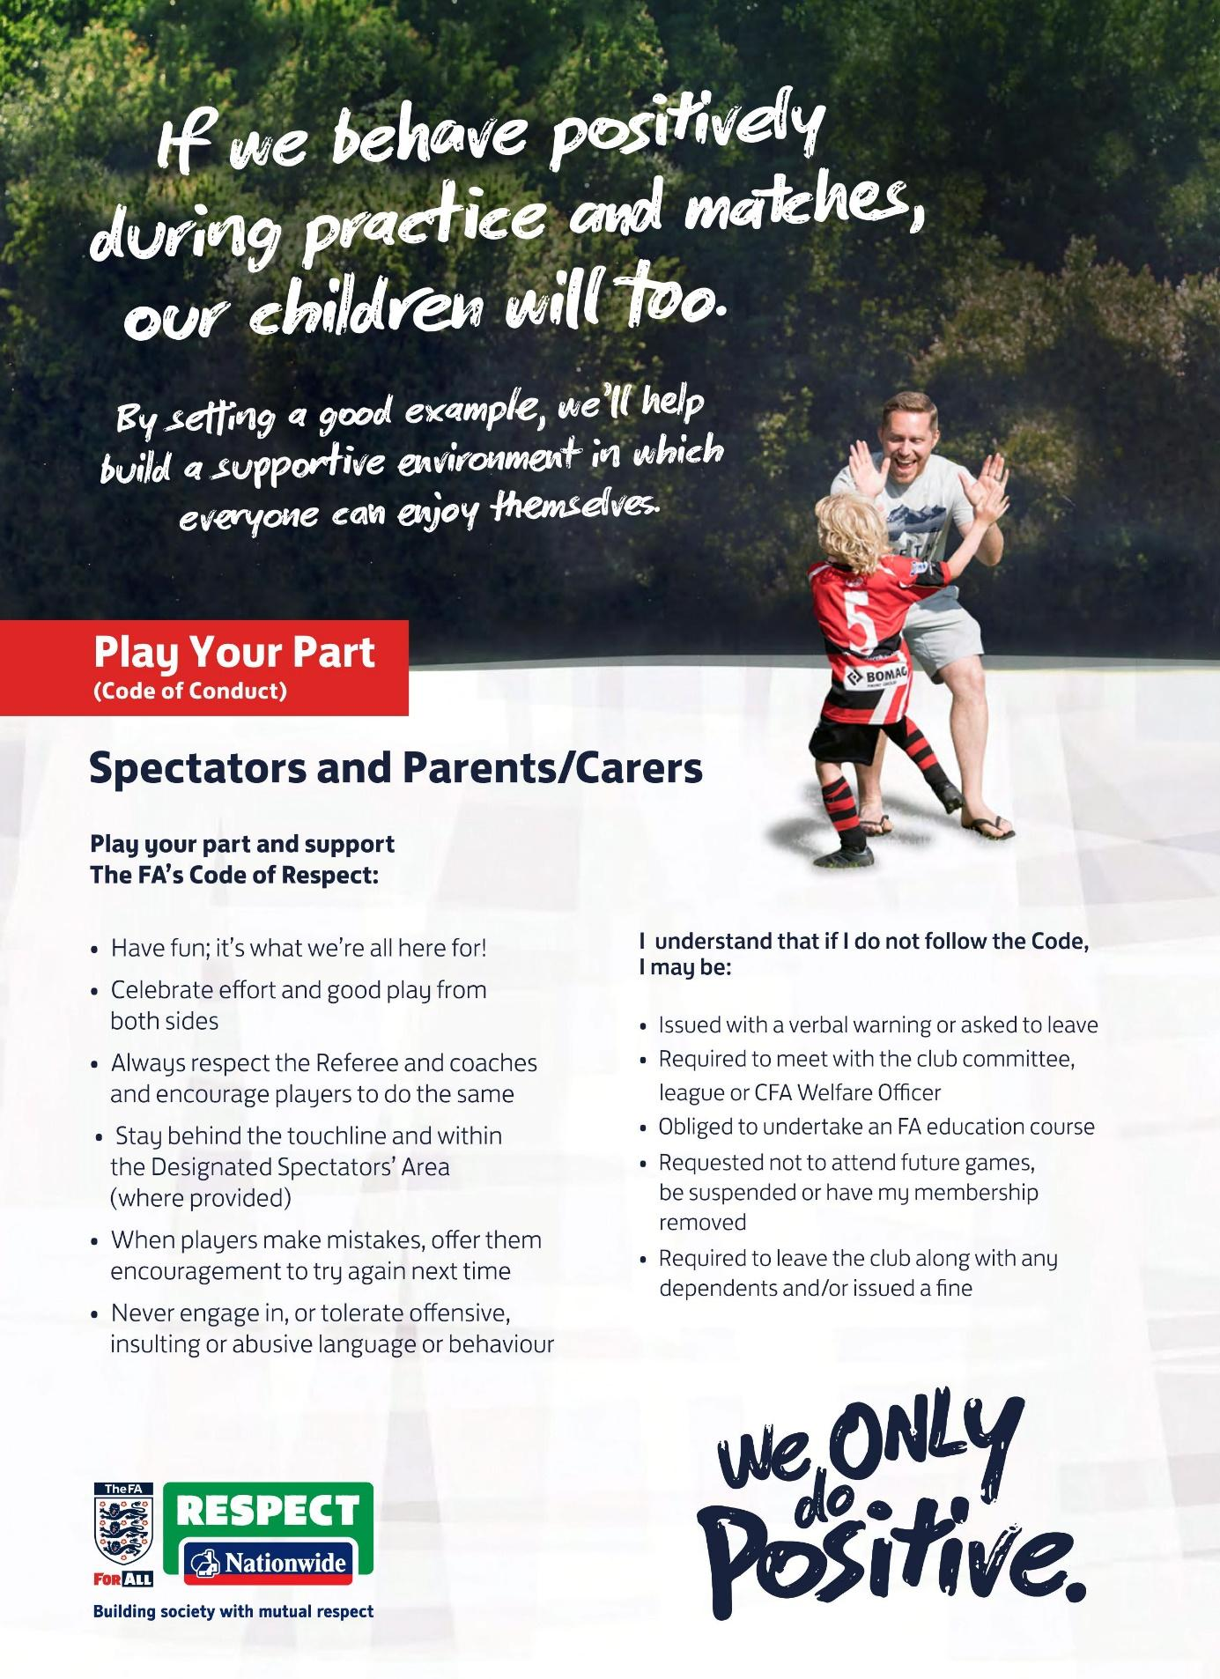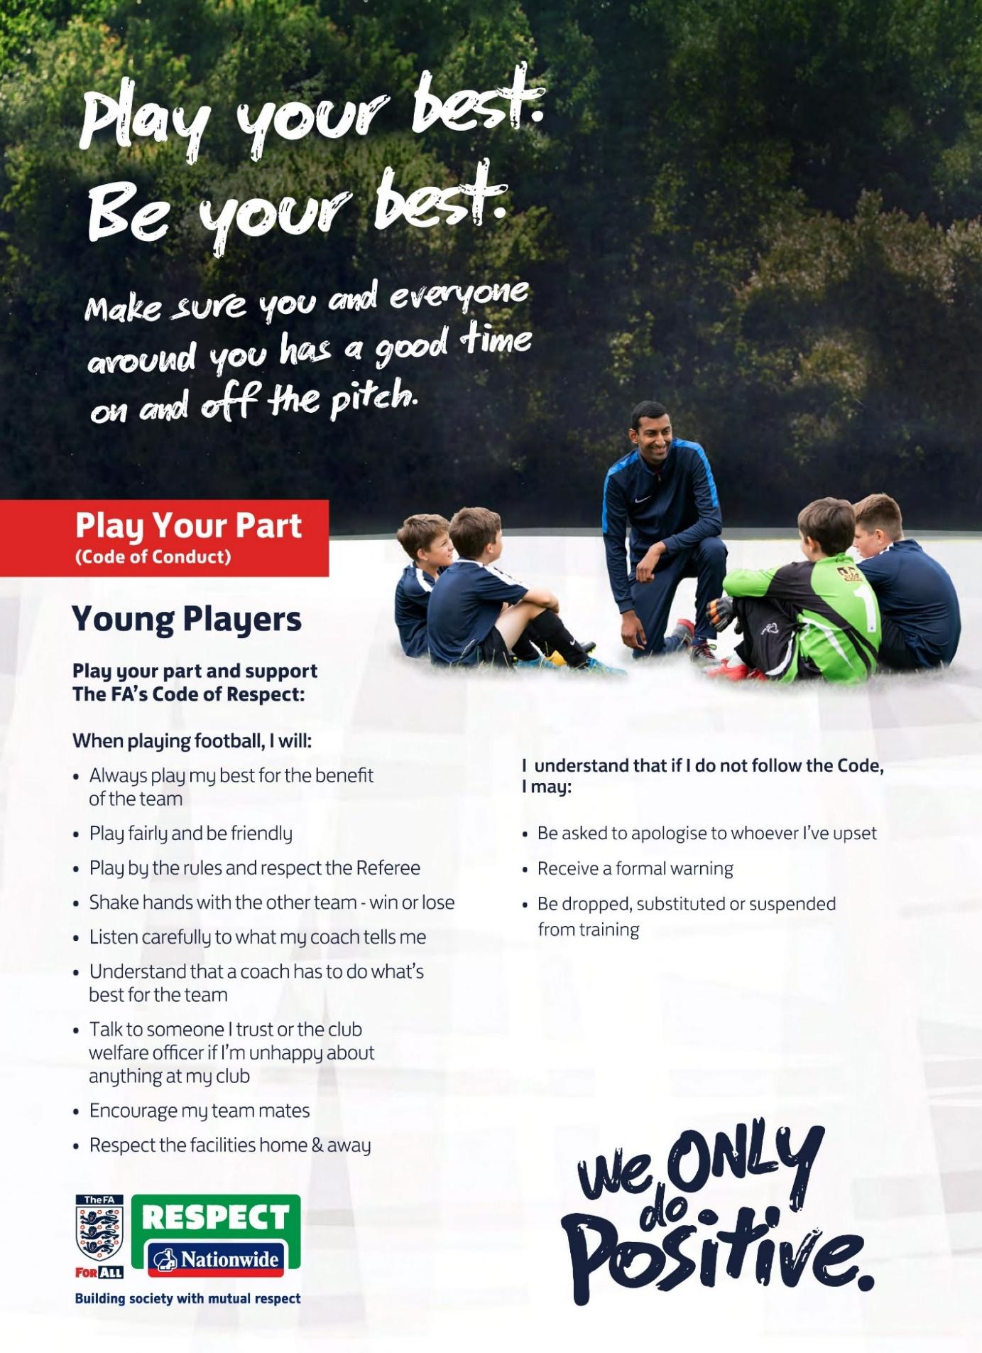

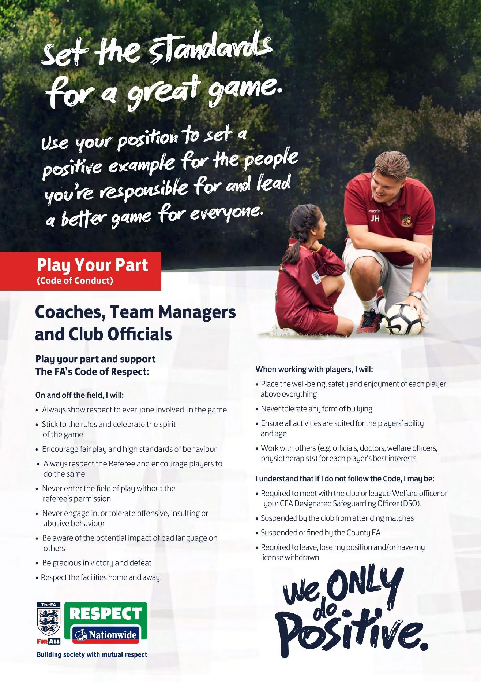
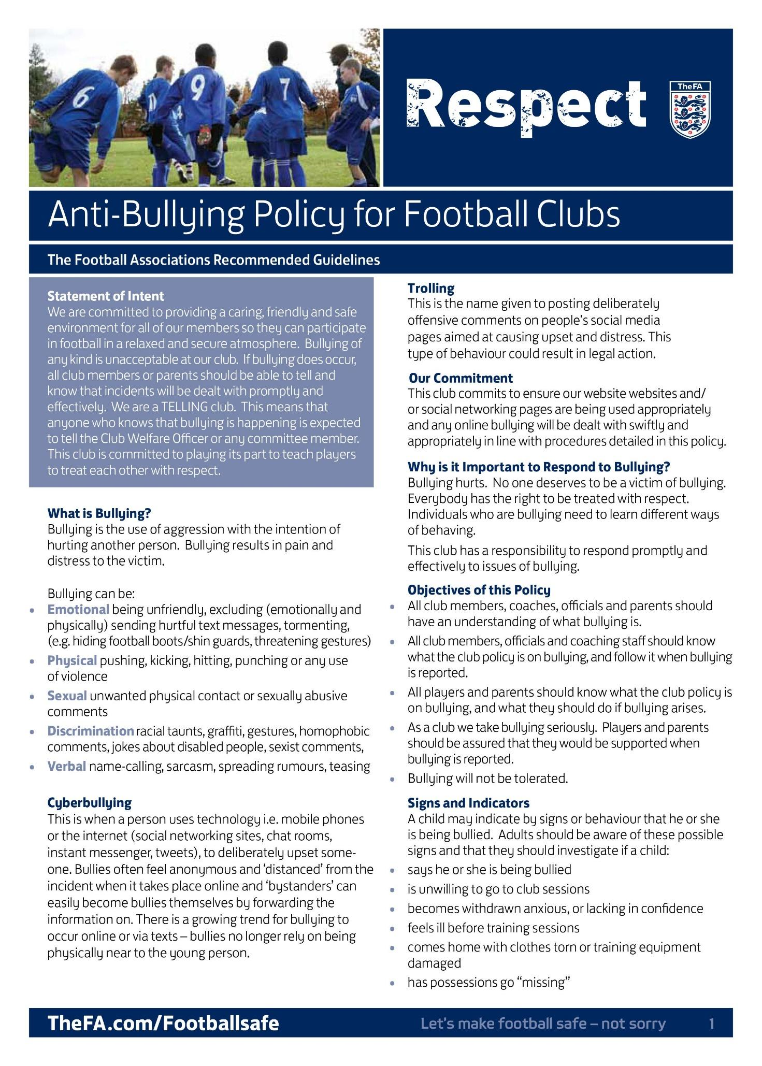
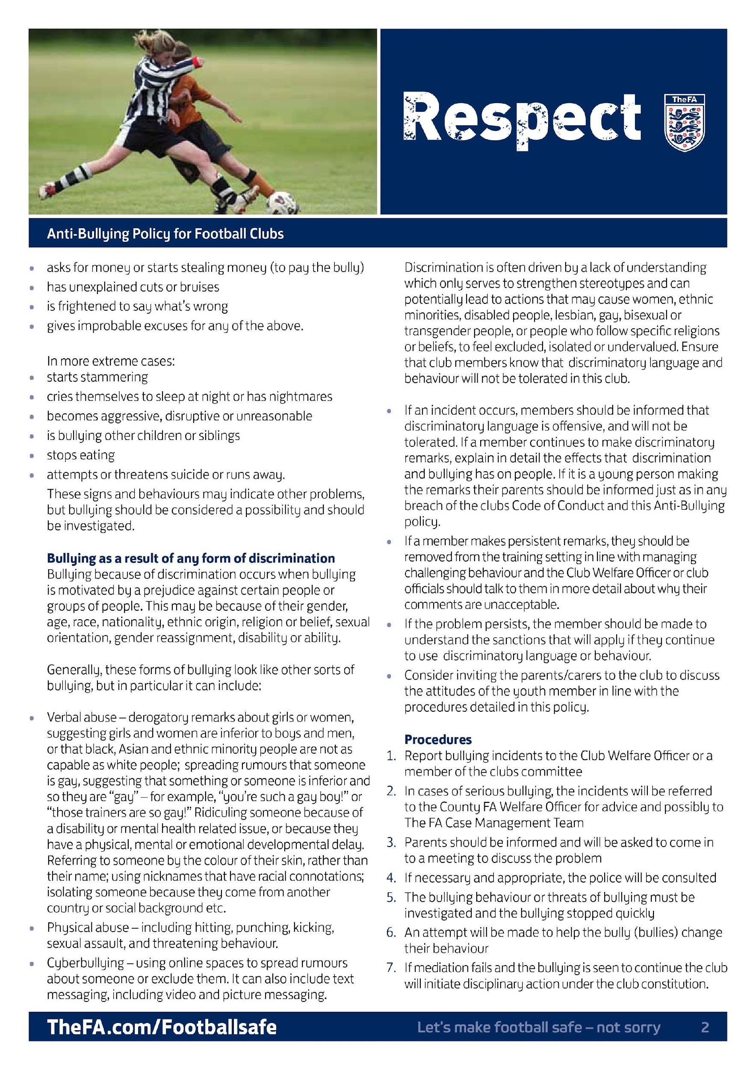
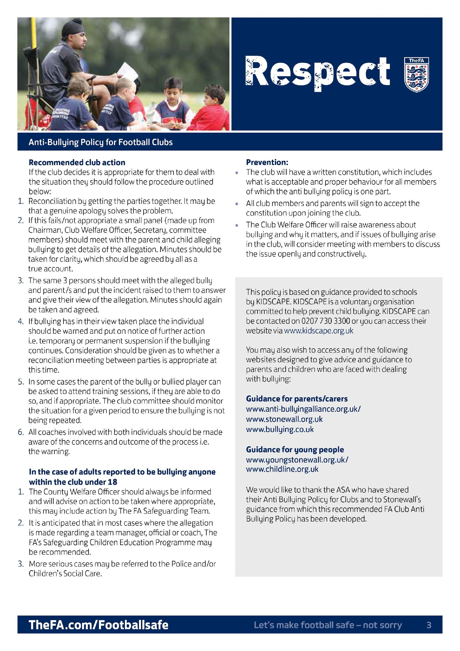

Appendix 2 – Purley Jubilee Referees programme
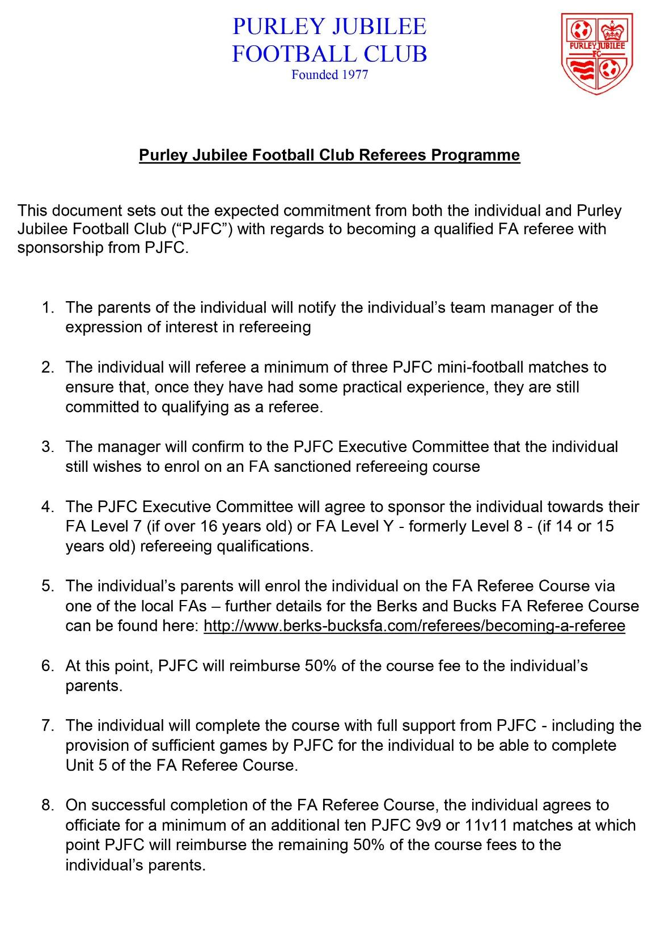

Appendix 3 – Social Media guidelines
PURLEY JUBILEE FC: SOCIAL MEDIA GUIDELINES
We are all very passionate about what we do and believe in open communication. You
are encouraged to tell the world about your passion for football.
Whether you do so by participating in a blog, online social network or any other form of
online publishing or discussion is completely up to you. However, these new ways of
communication are changing the way we talk to each other, which requires careful thought.
In order to avoid any problems or misunderstandings, we have come up with a few
guidelines to provide helpful and practical advice for you when operating on the Internet as
an identifiable member of the Purley Jubilee FC.
These guidelines are intended as a working document we can all take ownership of, and
they apply when updating any of the Purley Jubilee FC’s social media accounts (or sub-
accounts) and when posting about Purley Jubilee FC matters from personal accounts.
Using Personal Social Media Accounts
1. You are personally responsible for the content you publish on any form of user-generated
media, both internally and externally. Everything you publish will be visible to the world for a
very, very long time. Common sense is a huge factor here as grassroots football is a small
world!
2. When posting on social media from a personal account you could be considered as acting
as an official spokesperson so, if you are not, you must make clear that you are speaking for
yourself and not for Purley Jubilee FC.
3. If you are about to publish something that makes you even the slightest bit uncomfortable,
review it. If you are still unsure and it is related to the Purley Jubilee, talk to committee
member for a second opinion.
4. Sometimes you’ll be privy to sensitive information, which is absolutely not meant to be
forwarded to anyone who is not a member of Purley Jubilee FC.
5. It is perfectly fine to talk personally and have a dialogue with the community, though
involvement on sensitive debates which directly affect Purley Jubilee FC matters are
prohibited. If the judgement call is tough, please ask a senior committee member before you
publish or forward anything. Please act responsibly with the information you are entrusted
with.
6. Don&#39;t use ethnic slurs, personal insults, obscenities, or engage in any conduct which
would not be acceptable to the Purley Jubilee FC. You should also show proper
consideration for others’ privacy and for topics which may be considered objectionable or
inflammatory (like religion or politics).
7. Please respect intellectual property rights (such as trademarks and copyright). If the
name, logo, image, artwork or other material you want to use is not yours, don&#39;t use it.
Before posting someone else&#39;s work or image, please check with the owner first.
8. Be aware that others will associate you with Purley Jubilee FC when you identify yourself
as such. Please ensure that your Twitter, Facebook, Instagram or any other external-facing
profile and related content is consistent with how you wish to present yourself.
Using Purley Jubilee FC Social Media Accounts (or Sub-Accounts)

We currently have a Club Facebook group which is only accessible to authorised accounts
and access can only be granted by committee members, once users are approved, they are
able to post to the group, but posts will be moderated. In addition, we run a separate Club
Instagram account, with limited access to post content.
When posting on the Facebook group please remember it is not a personal account and any
posts should solely relate to Purley Jubilee or Grassroots football. Please be careful in
sharing content to the group particularly any content that could be deemed offensive or
abusive

Below are the FAs rules about social media and the consequences if as club we do not
follow them.
THE RULES:
It is against FA rules to post comments that are or maybe perceived as:
• Offensive.
• Insulting.
• Abusive.
• Threatening.
• Racist.
• Discriminatory.
• Any other reference that may cause offensive or harm to others.
Any such comment made on club or league websites and/or social networking sites
regarding match officials may result in disciplinary action being taken in line with the FA’s
disciplinary policies and procedures. Comments made on websites that are threatening,
abusive or racist could lead to legal action being taken against those responsible for posting
or hosting them. Comments made may attract libel claims and legal action through the civil
courts if they are untrue or defamatory. Children and young people should be advised by
their coaches, parents/carers and Club Welfare Officer to always tell an adult they trust about
communications that make them feel uncomfortable or where
they have been asked not to tell their parent/carer about the communication

